Thévenin’s Theorem

5-25 a Main Question (สำหรับแสดงข้อสอบ)

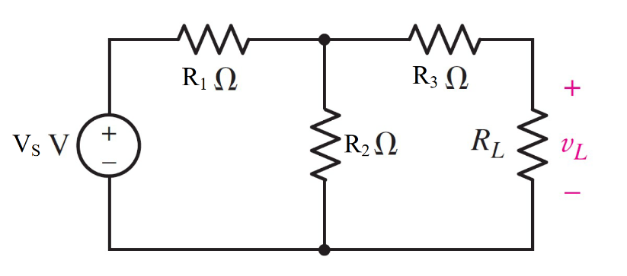

Given *E* = 9 V , *R*1 = 2 Ω, *R*2 = 3 Ω, *R*3 = 1 Ω. RL= 4 Ω

Find the Thévenin equivalent circuit for the network external to the resistor R.

*RTH* =

*VTH* =

Determine the maximum power to RL.

Variables (สำหรับเขียนโค้ดเพื่อหาคำตอบ)

Random variables

E = {1:10};

R1 = {1:10}; R2 = {1:10}; R3 = {1:10}; RL = {1:10};

Global variables

#E = 9; R1 = 2; R2 = 3; R3 = 1;RL= 4;

RTH = R1*R2/(R1+R2)+R3;

VTH = R2/(R1+R2)*E;

VL= (RL/(RL+RTH))*VTH;

P = (VL*VL)/(RL);

Part (กรอกคำตอบ)

1. RTH = 2.2 Ω

2. VTH = 5.4 V (assume the positive terminal of the voltage source is placed at the top)

3. P = 3.034

5-27 Main Question (สำหรับแสดงข้อสอบ)

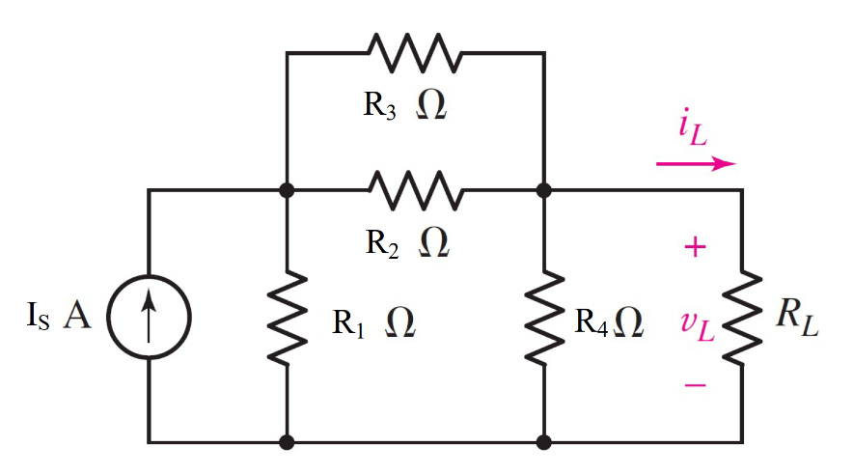

Given *Is* = 1 A , *R*1 = 0.8 Ω, *R*2 = 5 Ω, *R*3 = 5 Ω, *R*4 = 2 Ω,. RL= 4 Ω

Find the Norton equivalent circuit for the network external to the resistor R.

*RN* =

*ISC* =

Determine the maximum power to RL.

Variables (สำหรับเขียนโค้ดเพื่อหาคำตอบ)

Random variables

IS = {1:10};

R1 = {0.1:2:0.1}; R2 = {1:10}; R3 = {1:10}; RL = {1:10};

Global variables

#IS = 1; R1 = 0.8; R2 = 5; R3 = 5;R4 = 2;RL= 1;

R23 = R2*R3/(R2+R3);

RN = ((R23+R1)*R4)/(R1+R23+R4);

ISC = R1/(R1+R23)*IS;

IL= (RN/(RL+RN))*ISC;

P = (IL*IL)*(RL);

Part (กรอกคำตอบ)

1. RN = 1.2453 Ω

2. ISC = 0.2424 V (assume the positive terminal of the voltage source is placed at the top)

3. P = 0.0181 W

5-28 Main Question (สำหรับแสดงข้อสอบ)

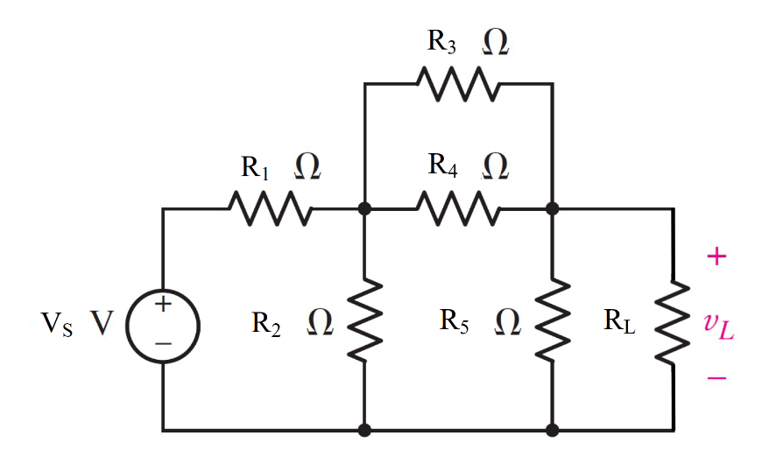

Given *E* = 4.2 V , *R*1 = 1800 Ω, *R*2 = 2500 Ω, *R*3 = 1100 Ω, *R*4 = 2300 Ω, *R*5 = 2500 Ω RL= 4700Ω

Find the Thévenin equivalent circuit for the network external to the resistor R.

*RTH* =

*VTH* =

Determine the maximum power to RL.

Variables (สำหรับเขียนโค้ดเพื่อหาคำตอบ)

Random variables

E = {1:10};

R1 = {1000:2000:100}; R2 = {2000:2500:100}; R3 = {1000:2000:100}; RL = {4000:5000:100};

Global variables

#E = 4.2; R1 = 1800; R2 = 2500; R3 = 1100; R4 = 2300; R5 = 2500 ; RL= 4700;

R34=(R3*R4)/(R3+R4);

R12=(R1*R2)/(R1+R2);

RTH = ((R12+R34)*R5)/(R12+R34+R5);

R2T = ((R34+R5)*R2)/(R34+R2+R5);

V2T = R2T/(R1+R2T)*E;

VTH = R5/(R34+R5)*V2T;

VL= (RL/(RL+RTH))*VTH;

P = (VL*VL)/(RL);

Part (กรอกคำตอบ)

1. RTH = 1043.3 Ω

2. VTH = 1.428 V (assume the positive terminal of the voltage source is placed at the top)

3. P = 288.4 µW

5-27 Main Question (สำหรับแสดงข้อสอบ)

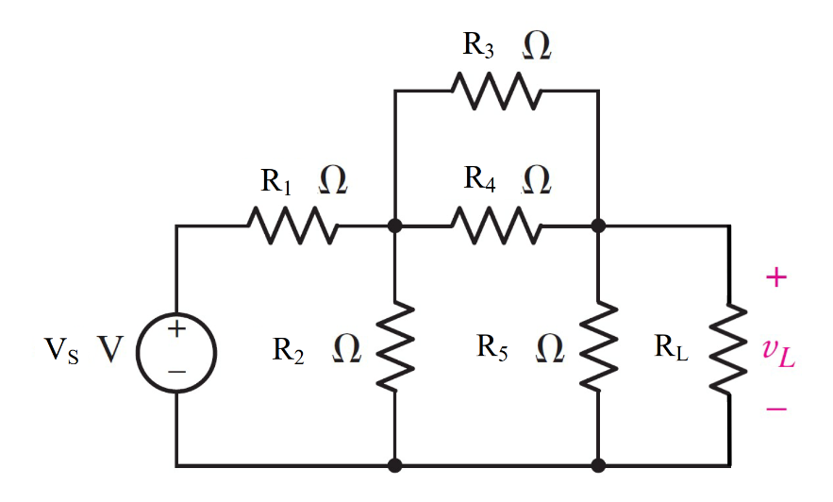

Given *E* = 4.2 V, *R*1 = 1800 Ω, *R*2 = 2500 Ω, *R*3 = 1100 Ω, *R*4 = 2300 Ω, *R*5 = 2500 Ω RL= 1700Ω

Find the Norton equivalent circuit for the network external to the resistor R.

*RN* =

*ISC* =

Determine the maximum power to RL.

Variables (สำหรับเขียนโค้ดเพื่อหาคำตอบ)

Random variables

E = {1:10};

R1 = {1000:2000:100}; R2 = {2000:2500:100}; R3 = {1000:2000:100}; RL = {1000:2000:100};

Global variables

# E = 4.2; R1 = 1800; R2 = 2500; R3 = 1100; R4 = 2300; R5 = 2500; RL= 1700;

IS=E/R1;

R34=(R3*R4)/(R3+R4);

R12=(R1*R2)/(R1+R2);

RN = ((R12+R34)*R5)/(R12+R34+R5);

ISC = R12/(R12+R34)*IS;

IL= (RN/(RL+RN))*ISC;

P = (IL*IL)*(RL);

Part (กรอกคำตอบ)

1. RN = 1043.3 Ω

2. ISC = 1.3637 mA (assume the positive terminal of the voltage source is placed at the top)

3. P = 457.2 µW

5-30 Main Question (สำหรับแสดงข้อสอบ)

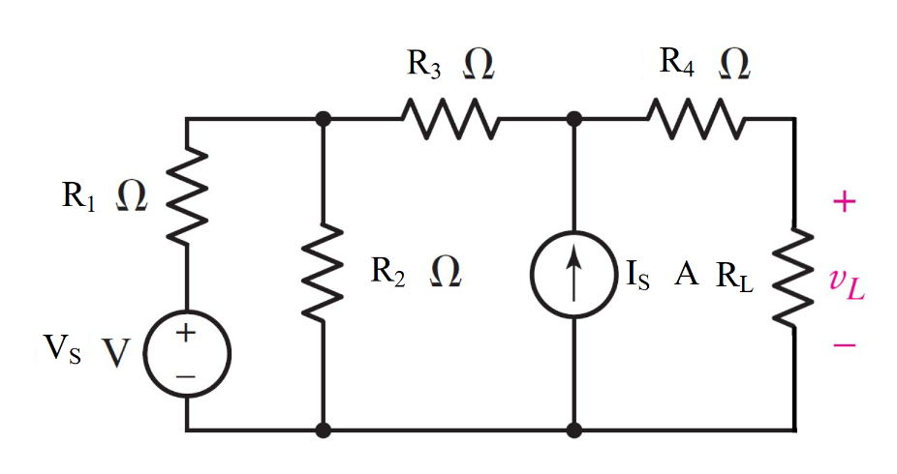

Given *E* = 0.7 V , *Is* = 0.3 A, *R*1 = 45 Ω, *R*2 = 122 Ω, *R*3 = 75 Ω, *R*4 = 220 Ω, RL= 100Ω

Find the Thévenin equivalent circuit for the network external to the resistor R.

*RTH* =

*VTH* =

Determine the maximum power to RL.

Variables (สำหรับเขียนโค้ดเพื่อหาคำตอบ)

Random variables

E = {0.1:1:0.1}; IS = {0.1:1:0.1}

R1 = {30:60:5}; R2 = {100:130}; R3 = {50:75:5}; RL = {100:200:10};

Global variables

#E = 0.7;IS=0.3; R1 = 45; R2 = 122; R3 = 75; R4 = 220; RL= 100;

R12=(R1*R2)/(R1+R2);

RTH = R12+R3+R4;

VTHV = R2/(R1+R2)*E;

VTHI =(R12+R3)*IS;

VTH = VTHV+ VTHI;

VL= (RL/(RL+RTH))*VTH;

P = (VL*VL)/(RL);

Part (กรอกคำตอบ)

1. RTH = 327.8 Ω

2. VTH = 32.87 V (assume the positive terminal of the voltage source is placed at the top)

3. P = 0.5903 W

5-34 Main Question (สำหรับแสดงข้อสอบ)

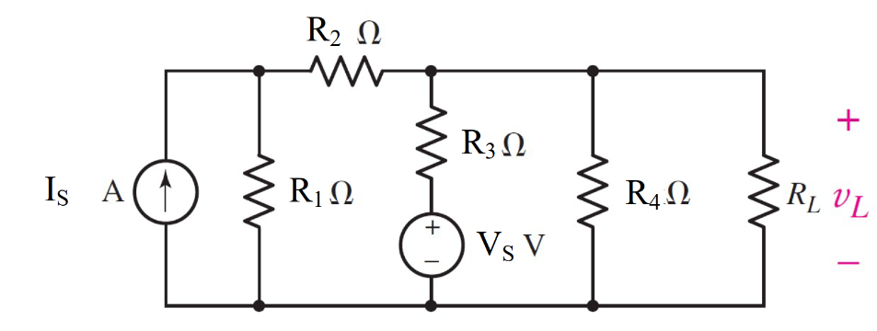

Given *E* = 2.5 V , *Is* = 0.3 A, *R*1 = 7000 Ω, *R*2 = 5000 Ω, *R*3 = 1000 Ω, *R*4 = 6000 Ω, RL= 3300Ω

Find the Norton equivalent circuit for the network external to the resistor R.

*RN* =

*ISC* =

Determine the maximum power to RL.

Variables (สำหรับเขียนโค้ดเพื่อหาคำตอบ)

Random variables

E = {0.5:3.0:0.5}; IS = {0.1:1:0.1};

R1 = {5000:7000:1000}; R2 = {1000:5000:1000}; R3 = {1000:5000:1000}; R4 = {5000:8000:1000}; RL = {2000:4000:100};

Global variables

# E = 2.5;IS=0.3; R1 = 7000; R2 = 5000; R3 = 1000; R4 = 6000; RL= 3300;

R12=R1+R2;

R3T=(R12*R3)/(R12+R3);

RN = (R3T*R4)/(R3T+R4);

ISCI= R1/(R12)*IS;

ISCV= E/R3;

ISC = ISCI+ISCV;

IL= (RN/(RL+RN))*ISC;

P = (IL*IL)*(RL);

Part (กรอกคำตอบ)

1. RN = 800 Ω

2. ISC = 0.1775 A (assume the positive terminal of the voltage source is placed at the top)

3. P = 3.9584 W

5-35 Main Question (สำหรับแสดงข้อสอบ)

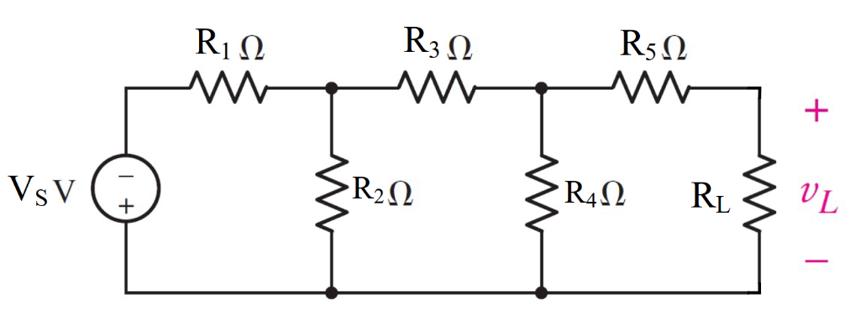

Given *E* = 2 V ,*R*1 = 10 Ω, *R*2 = 7 Ω, *R*3 = 20 Ω, *R*4 = 7 Ω, *R*5 = 30 Ω, RL= 10Ω

Find the Thévenin equivalent circuit for the network external to the resistor R.

*RTH* =

*VTH* =

Determine the maximum power to RL.

Variables (สำหรับเขียนโค้ดเพื่อหาคำตอบ)

Random variables

E = {1:5};

R1 = {5:40:5}; R2 = {5:10}; R3 = {5:20:5}; R4 = {100:130}; R5 = {5:40:5};

RL = {10:100:10};

Global variables

#E = 2; R1 = 10; R2 = 7; R3 = 20; R4 = 7; R5 = 30; RL= 10;

R12=(R1*R2)/(R1+R2);

R3T=R12+R3;

R4T=(R3T*R4)/(R3T+R4);

RTH = R4T+R5;

R2T = ((R3+R4)*R2)/(R3+R4+R2);

VR2 = R2T/(R1+R2T)*-E;

VTH = R4/(R3+R4)*VR2;

VL= (RL/(RL+RTH))*VTH;

P = (VL*VL)/(RL);

Part (กรอกคำตอบ)

1. RTH = 35.425 Ω

2. VTH = -185.25 mV (assume the positive terminal of the voltage source is placed at the top)

3. P = 166.32 µW

5-36 Main Question (สำหรับแสดงข้อสอบ)

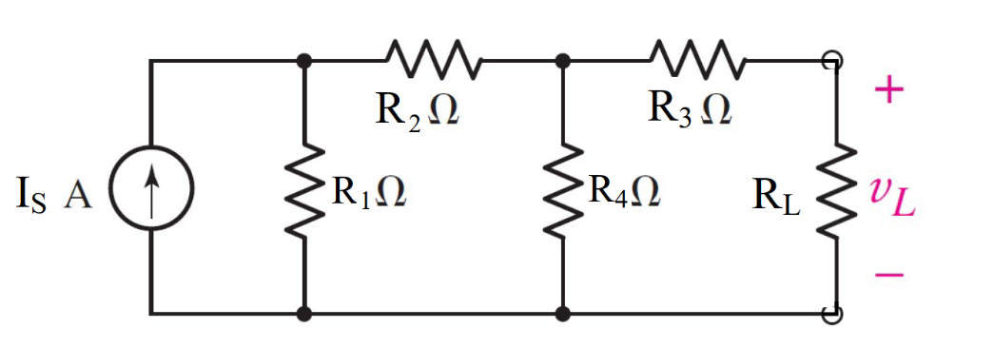

Given *Is* = 1 A ,*R*1 = 2 Ω, *R*2 = 1 Ω, *R*3 = 3 Ω, *R*4 = 4 Ω, RL= 10Ω

Find the Thévenin equivalent circuit for the network external to the resistor R.

*RTH* =

*VTH* =

Determine the maximum power to RL.

Variables (สำหรับเขียนโค้ดเพื่อหาคำตอบ)

Random variables

IS = {1:5};

R1 = {1:10}; R2 = {1:5}; R3 = {1:5}; R4 = {1:5};RL = {5:10};

Global variables

#IS = 1; R1 = 2; R2 = 1; R3 = 3; R4 = 4; RL= 10;

R12=R1+R2;

R4T=(R12*R4)/(R12+R4);

RTH = R4T+R3;

R2T = ((R3+R4)*R2)/(R3+R4+R2);

IR4 = R1/(R1+R2+R4)*IS;

VTH = R4*IR4;

VL= (RL/(RL+RTH))*VTH;

P = (VL*VL)/(RL);

Part (กรอกคำตอบ)

1. RTH = 4.714 Ω

2. VTH = 1.143V (assume the positive terminal of the voltage source is placed at the top)

3. P = 0.0603W

5-40 Main Question (สำหรับแสดงข้อสอบ)

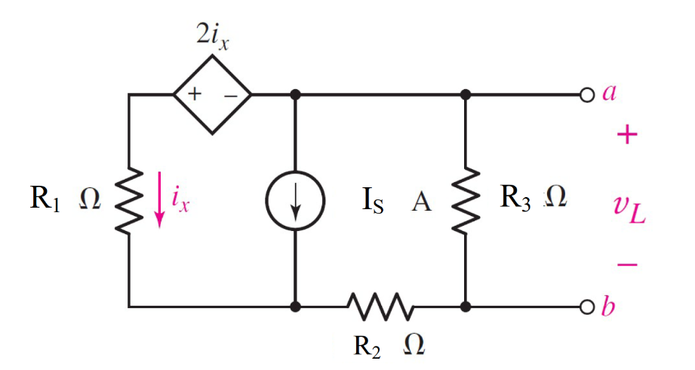

Given *Is* = 2 A ,*R*1 = 500 Ω, *R*2 = 2500 Ω, *R*3 = 1500 Ω, RL= 100Ω

Find the Norton equivalent circuit for the network external to the resistor R.

*RN* =

*Isc* =

Determine the maximum power to RL.

Variables (สำหรับเขียนโค้ดเพื่อหาคำตอบ)

Random variables

IS = {1:5};

R1 = {100:500:100}; R2 = {1000:5000:500}; R3 = {1000:4000:500}; RL = {100:500:100};

Global variables

#Is = 2; R1 = 500; R2 = 2500; R3 = 1500; RL=100;Itest=1;

G11 = 1/R3; G12 = 1/(R1+R2); G21 = -1; G22 = 1-1/R3;

Z11 =2-R1; Z12=R2; Z21 = -1; Z22 =-1;

I1 = Itest; I2 = 0; V1=0; V2=Is;

D = G11*G22-G12*G21;

D2= Z11*Z22-Z12*Z21;

D1IS = I1*G22-I2*G12;

D1ES = V1*Z22-V2*Z12;

D2IS = G11*I2-G21*I1;

D2ES = Z11*V2-Z21*V1;

Vx = D1IS/D; Va = D2IS/D; ISC = D1ES/D2; Ix = D2ES/D2;

RN=Vx/Itest;

IL= (RN/(RL+RN))*ISC;

P = (IL*IL)*(RL);

Part (กรอกคำตอบ)

1. ISC = -1.6678 A
2. Rn = 999.77 Ω
3. P = 229.865 W

5-41 Main Question (สำหรับแสดงข้อสอบ)

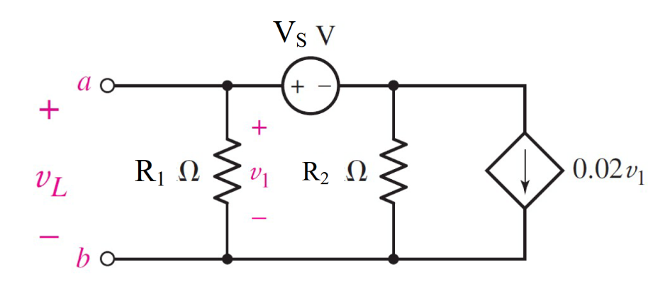

Given *Es* = 1 A ,*R*1 = 10000 Ω, *R*2 = 20000 Ω, RL= 5 Ω

Find the Thévenin equivalent circuit for the network external to the resistor R.

*RTH* =

*VTH* =

Determine the maximum power to RL.

Variables (สำหรับเขียนโค้ดเพื่อหาคำตอบ)

Random variables

VS = {1:5};

R1 = {5000:10000:1000}; R2 = {10000:20000:1000}; RL = {5:100:5};

Global variables

#Es = 1; R1 = 10000; R2 = 20000; RL=5;Itest = 1;

G11 = 1/R1+0.02; G12 = 1/R2; G21 = 1; G22 = -1;

I1 = 0; I2 = Es;

D = G11*G22-G12*G21;

D1 = I1*G22-I2*G12;

D2 = G11*I2-G21*I1;

V1 = D1/D; V2 = D2/D;

VTH=V1;

Vtest=1/(0.02+1/R1+1/R2);

RTH = Vtest*Itest;

VL= (RL/(RL+RTH))*VTH;

P = (VL*VL)/(RL);

Part (กรอกคำตอบ)

1. RTH = 49.6278 Ω
2. VTH = 0.0025V (assume the positive terminal of the voltage source is placed at the top)
3. P = 10.318 nW